# Request User Login

Please send an email to [DevServices@corp.ds.fedex.com](mailto:DevServices@corp.ds.fedex.com) to be added to an organization. These orgs are usually lined up along SVP or VP orgs – if you have a specific org you would like created please indicate in your request. An email will be sent back to you once you’ve been added.

# Log into the Sonatype CLM Server

[http://djb00100.ute.fedex.com:8070/assets/index.html](http://djb00100.ute.fedex.com:8070/assets/index.html%20%20) Use empID for both the as username and password (NO LDAP)

Click on the “Organizational Design” icon: 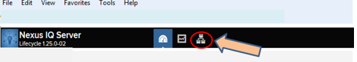

# Organization / New Application

You should see the org for your SVP/VP area – click the “new application” button.

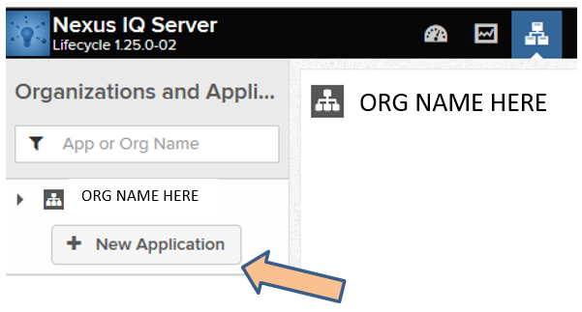

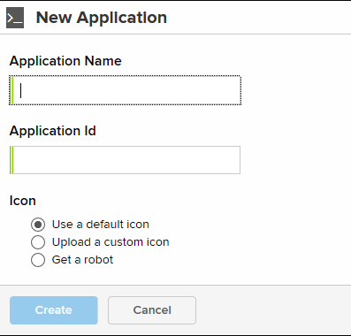

# Create an Application in your org

Fill out the form with the application name and application ID#. If you are using this software with an EAI application then use that specific application; if you don’t have an application then you can ‘create’ a temporary application for use here. Nothing complicated – a simple name and ID# - your empID should work fine. Leave the icon default. NOTE: duplicates are not allowed; if you get an “ID is already in use” then add a digit or two to comply.

# Upload and scan your app

You should see your app name at the top of the screen. Go to drop-down ‘Actions’ and choose “Evaluate Binary”

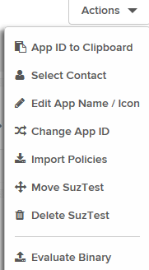

Use the browse button to find and upload your software binary. Set the stage as “build” and leave notifications set to “yes”

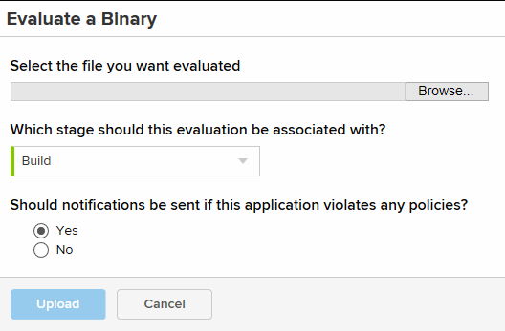

# View your report

A PDF report containing a Bill of Materials of all open source products that were detected will be produced for you app. You can also view your app report online in the CLM Server.

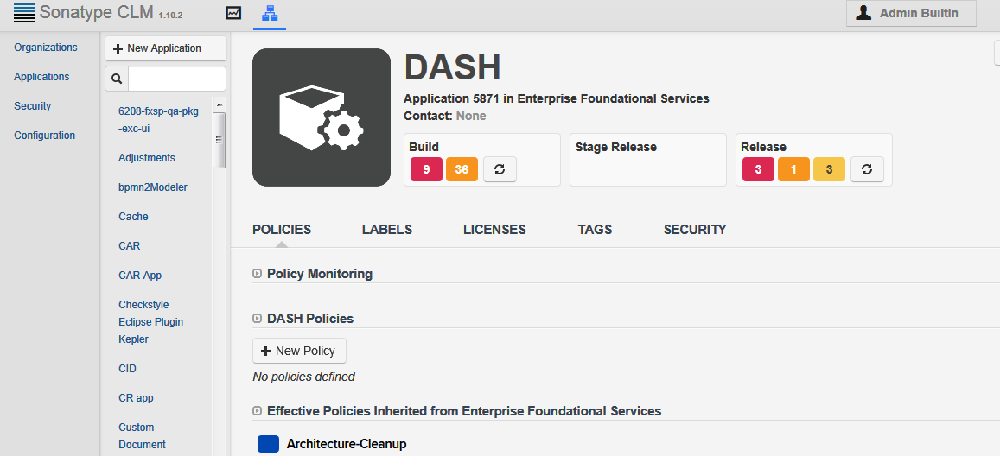

Clicking one of the policy violation numbers will take you to the summary report:

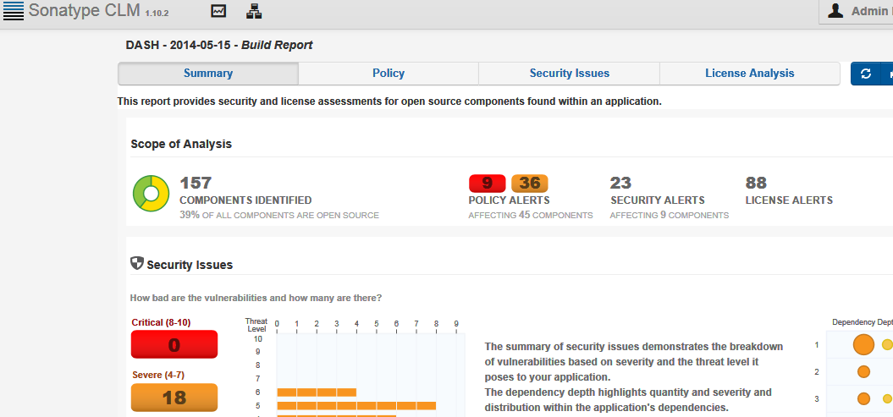

Additional CLM [documentation](http://books.sonatype.com/sonatype-clm-book/html/index.html?__utma=53622698.446128125.1390251450.1402495134.1402589297.17&__utmb=53622698.1.10.1402589297&__utmc=53622698&__utmx=-&__utmz=53622698.1402589297.17.15.utmcsr=google|utmccn=(organic)|utmcmd=organic|utmctr=(not%20provided)&__utmv=-&__utmk=137928820) is available online. The “Report User Guide” is useful in explaining the contents of a report.

# Save this pdf document as you’ll attach this to your FOSS request